Learning to TEACH
Aditi Padhi (TSA ’12)

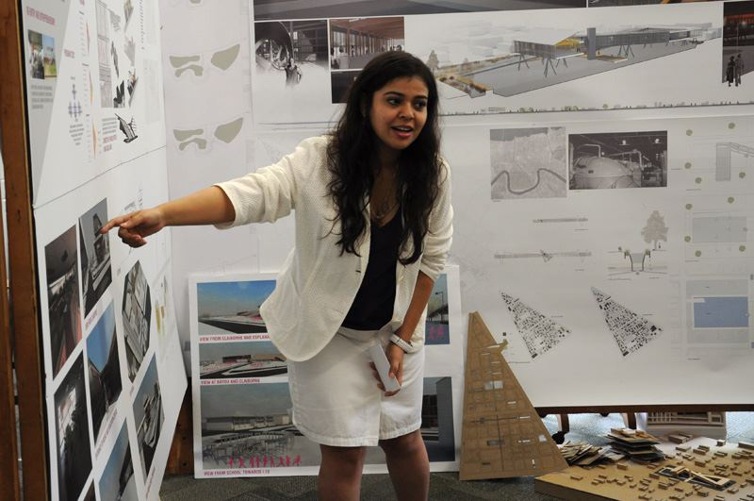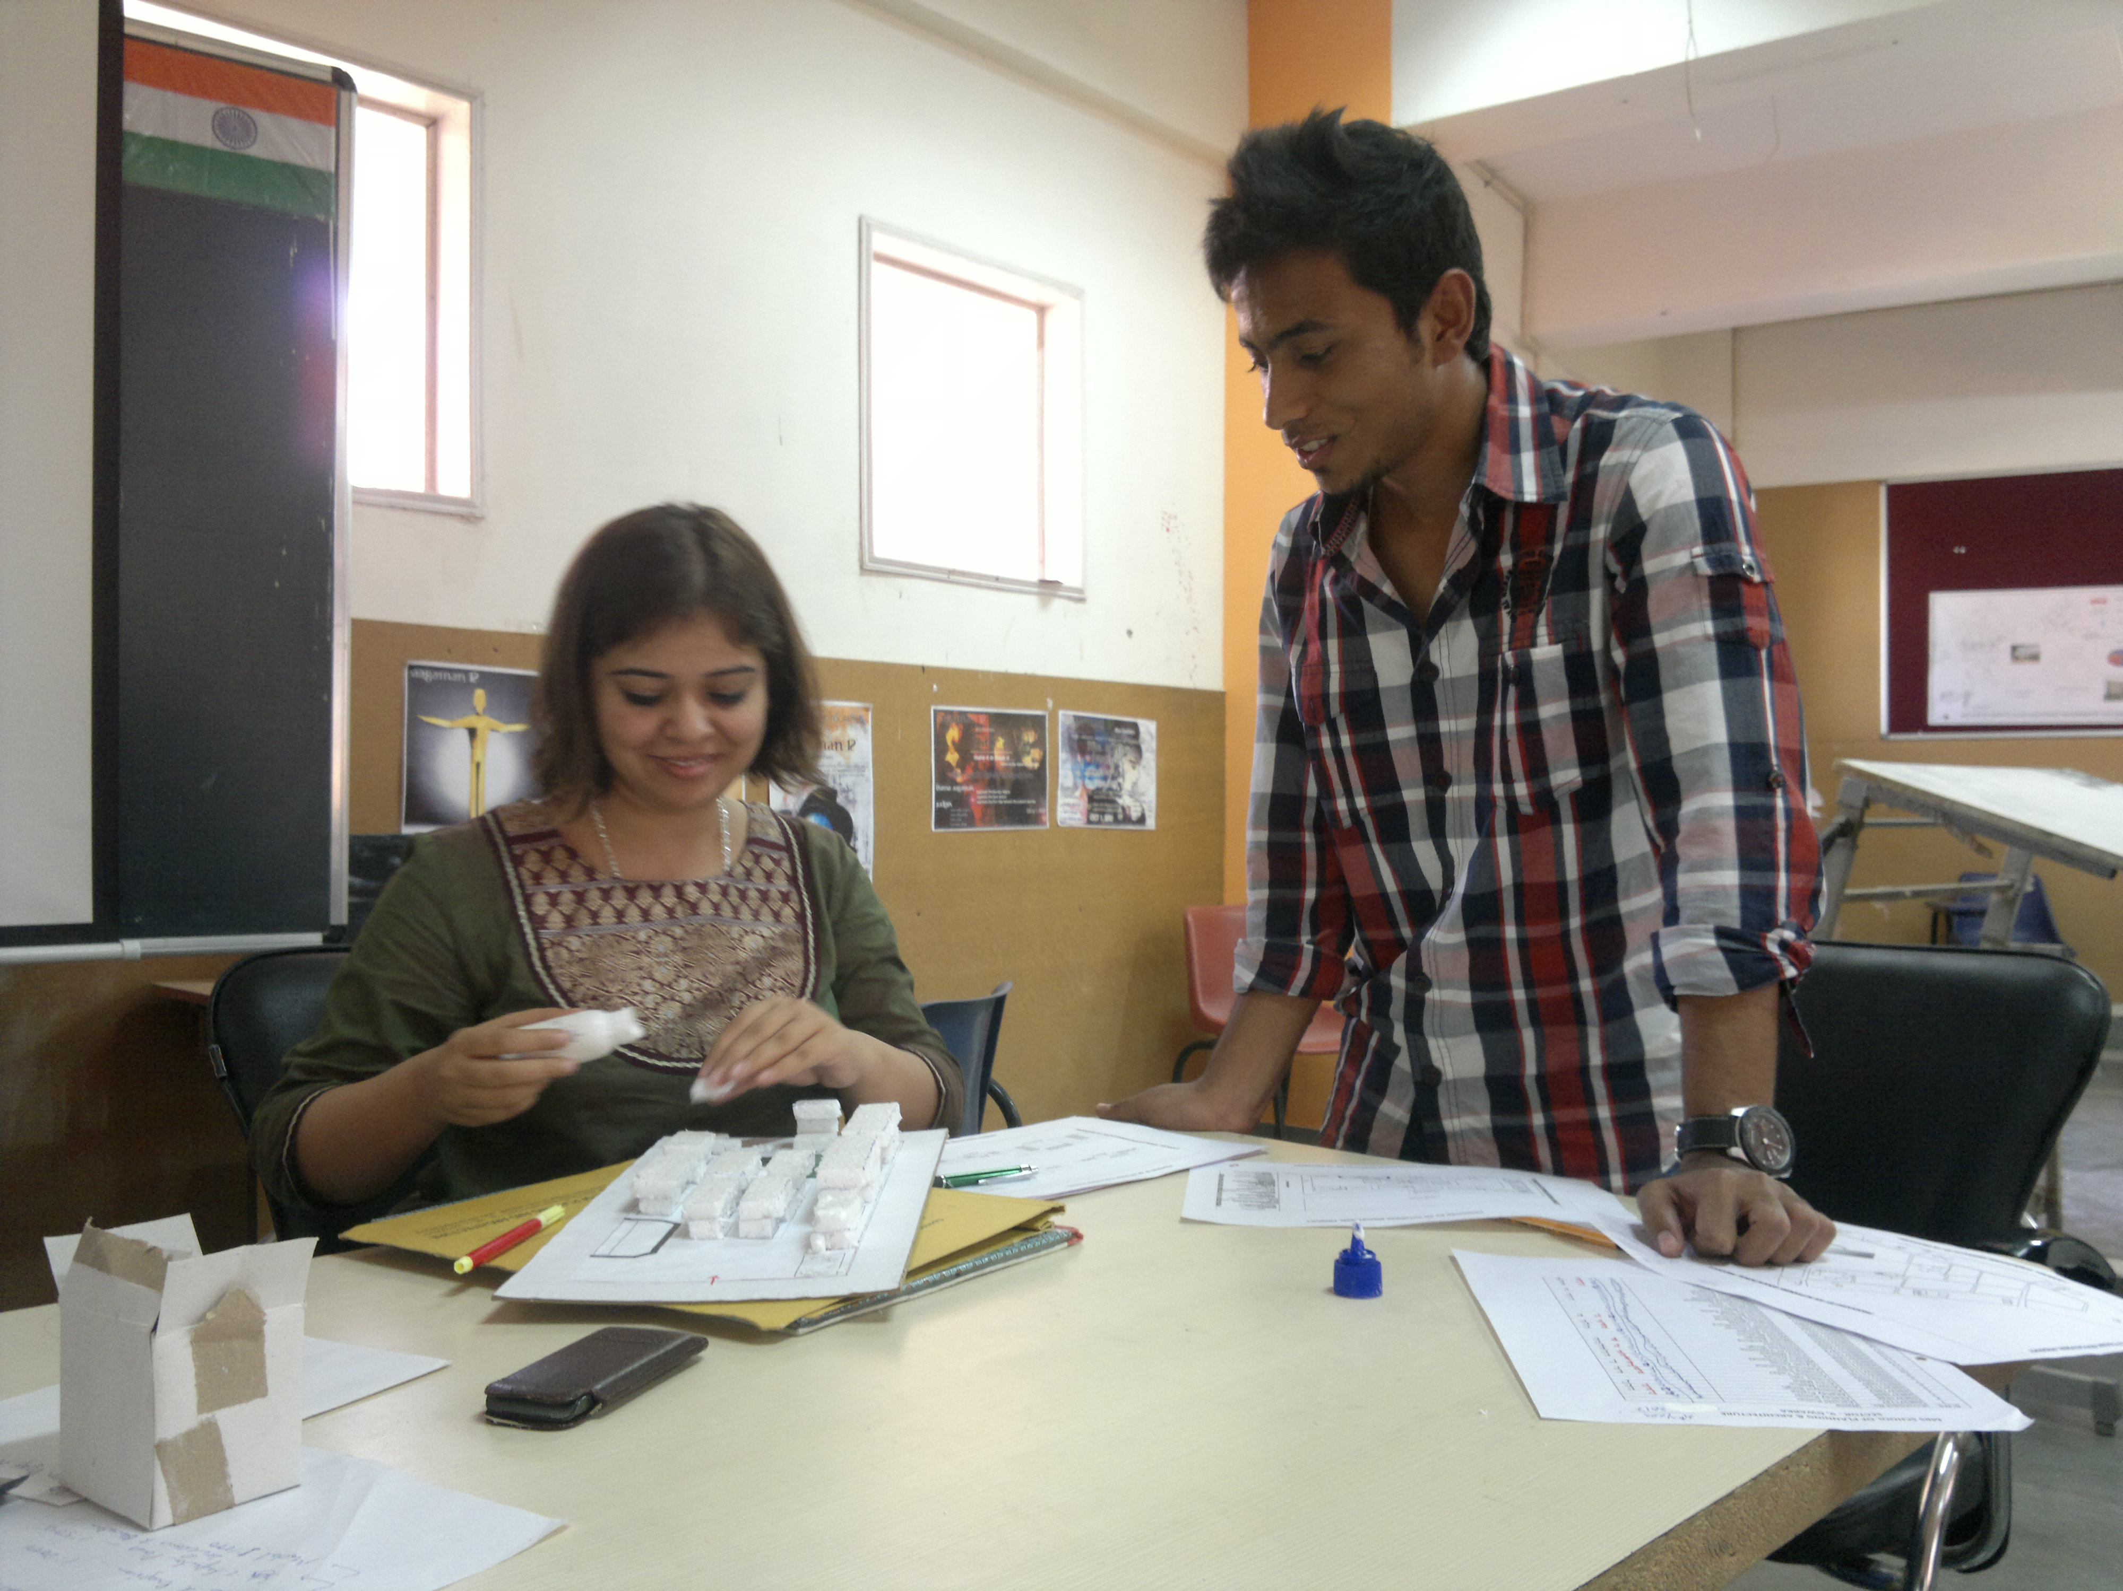

The fulfilling of a lifelong ambition, my acceptance to Tulane school of Architecture came to me after nearly a decade of practice in Asia. I remember my tentative first presentations and my lack of confidence in communicating my ideas. Armed with only the knowledge to design and a thirst for more, I was lifted from the shadows by teachers, accomplished educators and mentors the kind I had never imagined existed. My studio director, my thesis guide, my professors never let me give up and never gave up on me. This very foundation became the basis of my very first design studio at MBS School of Planning and architecture, New Delhi, INDIA

In this URBAN DESIGN STUDIO for undergraduate students - Aug. 2012- Dec. 2012, ‘Reinterpretation of “CIVIC CENTRE” Design – A Paradox’ I hoped to assimilate both my practical experience of working for the city of New Delhi and my academic pursuits explored in both my option studio project "Redistribution of North Claiborne Neutral ground to revive the historical Treme district of New Orleans"- and my Thesis- "Urban Centre for Justice re-investment: Rehabilitation in Treme-seventh ward, New Orleans”. As studio director now in MBS, I hoped to further my design explorations that began in TSA through my own project works.

The context of the studio is Gurgaon, India : a new city... a new language to define itself as a city...a new urban centre ..to fulfill the aspirations of a younger society with new demands yet set in the cultural norms of the past. The roots remaining the same the expressions and the means of fulfillment have changed. The end objective of the studio was to address this very paradox through the design of a CIVIC CENTRE of TODAY. The aspiring undergraduates were introduced to ideas of living collectively but practicing individuality, addressing the challenge of providing community spaces and issues of security and maintenance as one of the prime concern in the design of such public spaces. Lectures were conducted to further understand urban design strategies, concepts of city identity and landmark, reciprocity of spaces to the social milieu and the outcome of changing socio- cultural lifestyle and synergies to promote a healthy lifestyle. The design program hopes to address the social needs of people with different economic status, the flexibility of spaces that have provision for future, changing trends with increasing participation of woman in society. Some spaces like Child Support Centre, Day Care facility introduced speaks of the gender equality and woman empowerment and acceptance in modern society. The other spaces of the program aim to make the proposed Civic Centre a major business centre catering to an equally strong residential sector.

As I prepare to return to TSA in Spring, 2013, the combination of my own graduate education and conducting undergraduate coursework as a studio co-coordinator and the successful completion of this studio would place me in position to do greater justice to my future pursuits. I remain most grateful to Dean Schwartz for his guidance, foresight and support.

